Database System Engineering and Distributed Backend Development
Course Code: 25CS13002E
DDL, DML, DCL, TCL COMMANDS 2520030531
D. Venya Sri
Query 1: Create Database
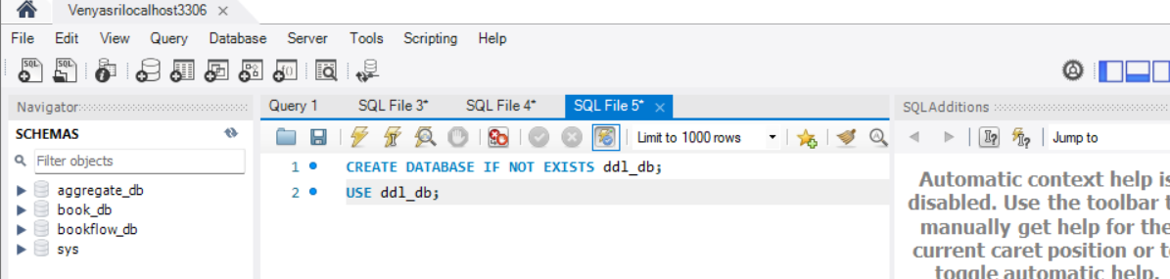
OUTPUT

Query 2: Create Table
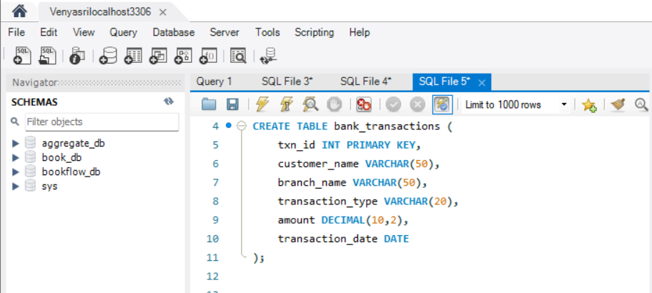

OUTPUT
Query 3: Alter Table Add Column
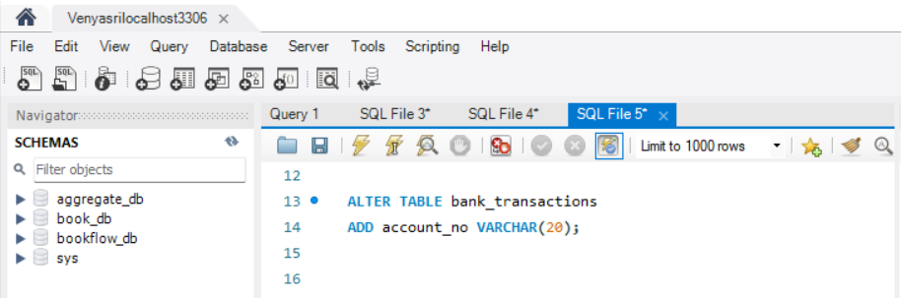

OUTPUT

Query 4: Alter Table Modify Column
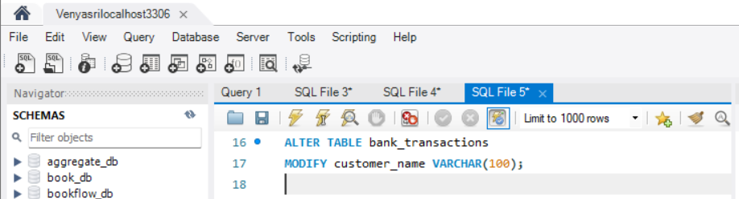

OUTPUT
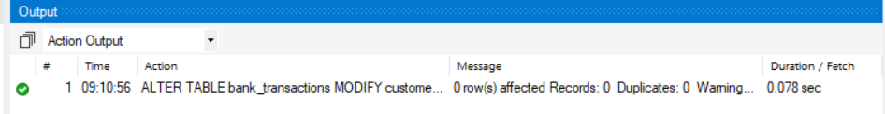

Query 5: Rename Table
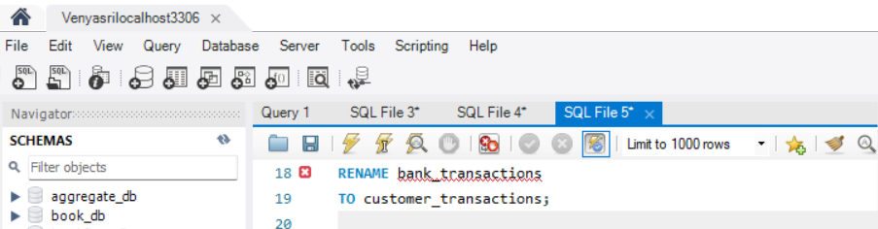
OUTPUT

Query 6: Truncate table
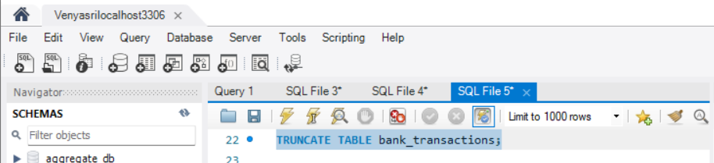
OUTPUT

Query 7: Dropa Table
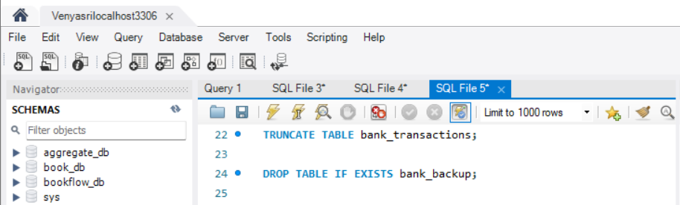

SECTION: DML Manupulation
Query 8: Insert Sample Data
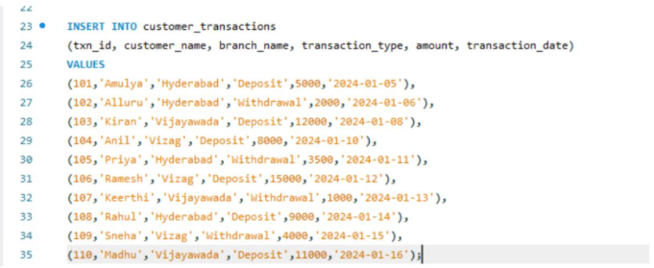
OUTPUT

Query 9: Update
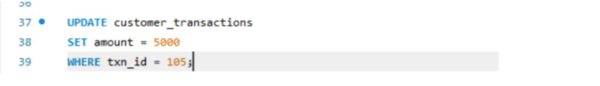
Output

Query 10: Delete
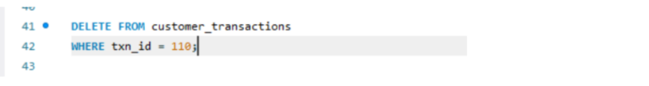
Output

Query 11: Select
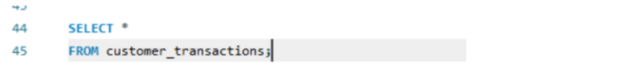
Output
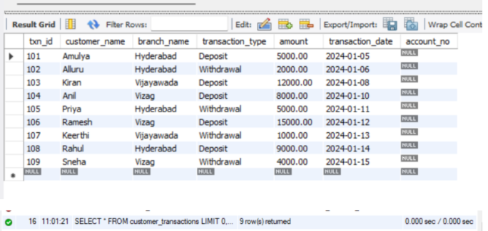
Query 12: Select With Where
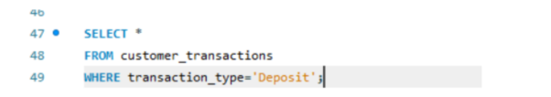
Output
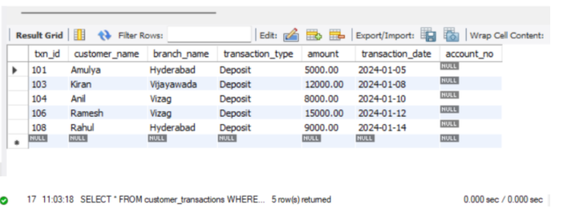

Query 13: Select With Order By
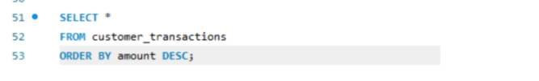
Output
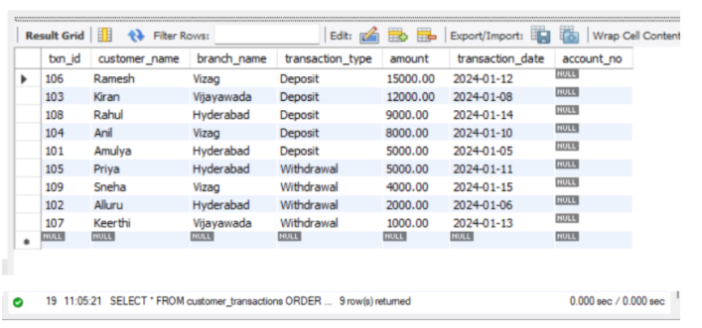
Section 3: DCL (Data Control Language)
Query 14: Grant Select
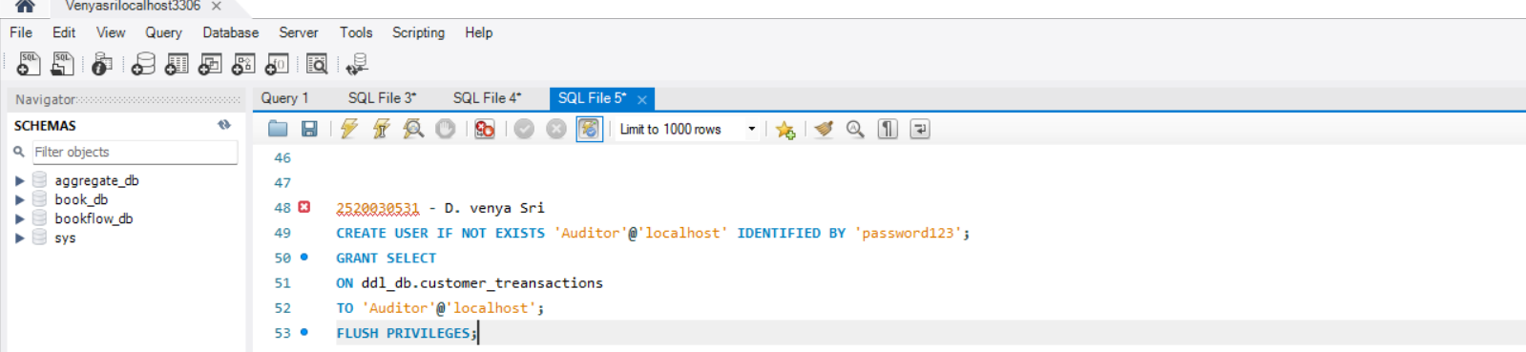
OUTPUT
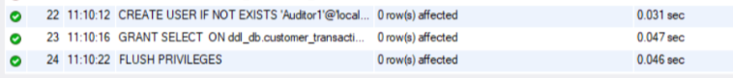

Query 15: Grant All Privileges
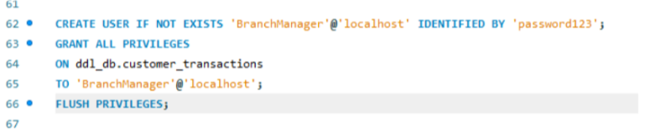
Output
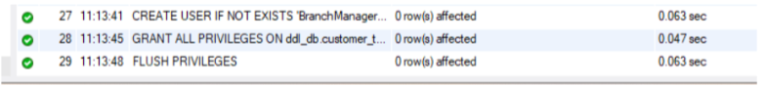
Query 16: Revoke Select
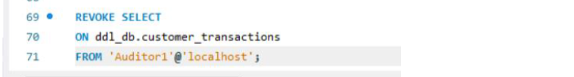
Output
Query 17: Revoke All
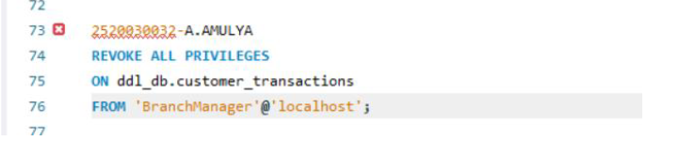
Output

Section 4: TCL (Transaction Control Language)
Query 18: Commit
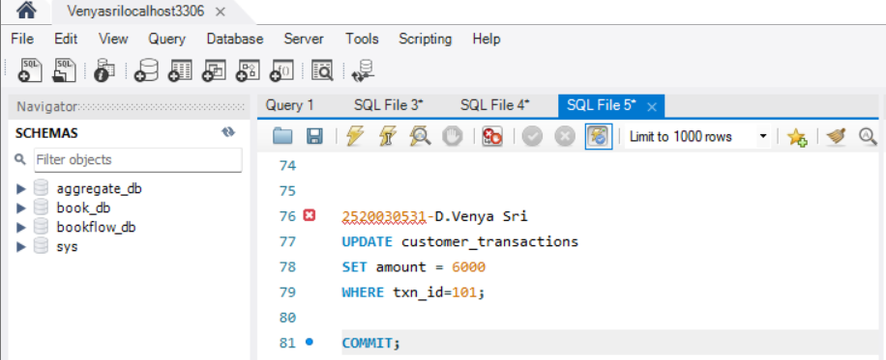
Output
Query 19: SAVEPOINT
Output
Query 20: ROLLBACK To SAVEPOINT
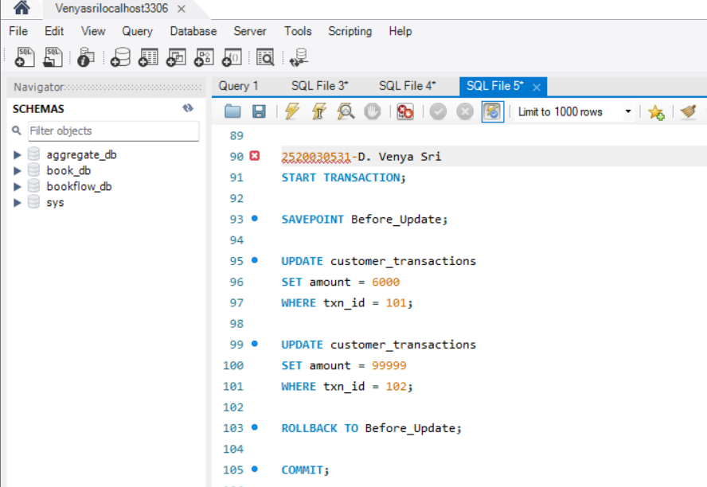
Output
